
D O K U Z E Y L Ü L U N I V E R S I T Y
FACULTY OF ENGINEERING

COMPUTER ENGINEERING DEPARTMENT

Project Final Report

Course : CME1101 - Project Based Learning -1
Project No : Lab 5 Date: 05.11.2012
Project Name : Tic Tac Toe

Prepared By : Group/Subgroup No:

Members: No: Name:
1. 2011510105 Berkay Türkgeldi
2. 2010510094 Ahmed Alhammadı
3. 2008510050 Adnan Tuğ
4. 2009510046 Ali Konya

1. Project Description
Give summarized details about project; purpose and scope of the project, start and completion dates. Give any background information you have researched to complete the project.

The aim of the project is to develop a two-player 3*3 board game. The project has easy, medium, hard difficulties and user can choose one of them. The project finished in third week and then we prepeared poster and presentation.

2. Task Summary

2.1. Completed Tasks
Member | Task
Berkay Türkgeldi | Degree of difficulties development, designing of while loop, prepearing a presentation
Ali Konya | Using if…else statements, play of ‘O’ with reference to ‘X’ fields, prepearing the project poster
Adnan Tuğ | Designing of screen area, using if statements to control wrong input, prepearig a presentation
Ahmed Alhammadı | Definition of variables, adding comment lines, play of ‘X’, prepearing the project poster

2.2. Uncompleted Tasks
Member | Task and Reason
Berkay Türkgeldi | User can play a string instead of number. In this case, an error occurs and the program will end immediately  It can be used try-catch statements but, because of the topics which have not discussed in the first classes, we thought we should not use them
Ali Konya
Adnan Tuğ
Ahmed Alhammadı

2.3. Additional Improvements to the Project
Member | Additional Improvement
Berkay Türkgeldi | Levels
Ali Konya | Error control
Adnan Tuğ | Table
Ahmed Alhammadı | Tour control

3. Explanation of Algorithms

3.1. Screenshots
Explain the functionality of your solution by using key screenshots.

We have used while loop to do not write same codes again and again.

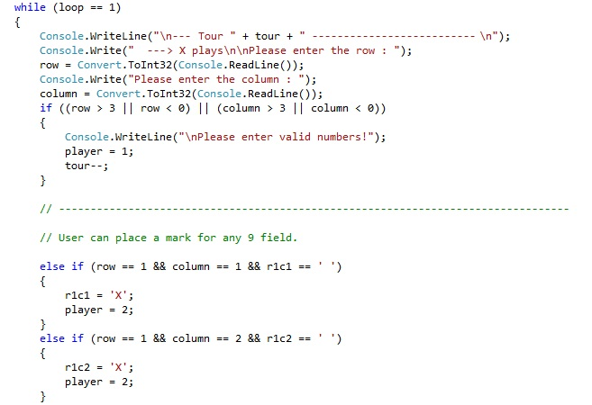

…

3.2. Functions
Give list of functions and parameters.

cahr r1c1,r1c2,r1c3,r2c1,r2c2,r2c3,r3c1,r3c2,r3c3
int row,column,player,loop

3.3. Algorithms
Explain important algorithms and solution strategies in the project with code extracts. Use flowcharts if necessary.
Member | Algorithm/Solution strategy
Berkay Türkgeldi | In easy level, the computer plays unimportant fields in any empty area. Otherwise, the level will be automatically medium and hard level is inside of medium level
Ali Konya | Designing play of ‘O’ with reference to placed marks.
Adnan Tuğ | Designing the screen and inserting the variables into tha table
Ahmed Alhammadı | Designing play of ‘X’ and defining order of priorities

4. Problems Encountered
Member | Problems and Solutions
Berkay Türkgeldi | Probability of placing a mark in a field which has already marked
Ali Konya | Increment the tour variable wrongly in some cases
Adnan Tuğ | Increment the tour variable wrongly in some cases
Ahmed Alhammadı | Losing condition does not occur despite if statement

5. Conclusions
Summarize your work, describe what you have learned from the project both technically and socially.

First of all, this project is the first project for some of us. The project improves our team work. Technically, we have learned how to use basic statements. On the other hand, we have learned the logic of loop statement and we have used while loop. Finally, we have learned try-catch-finally statements but we did not use them.

6. References

ocw.mit.edu/courses/electrical-engineering-and-computer-science

7. Appendices
7.1. Poster/Web page of the Project
Give picture of poster or some key screens from web page.
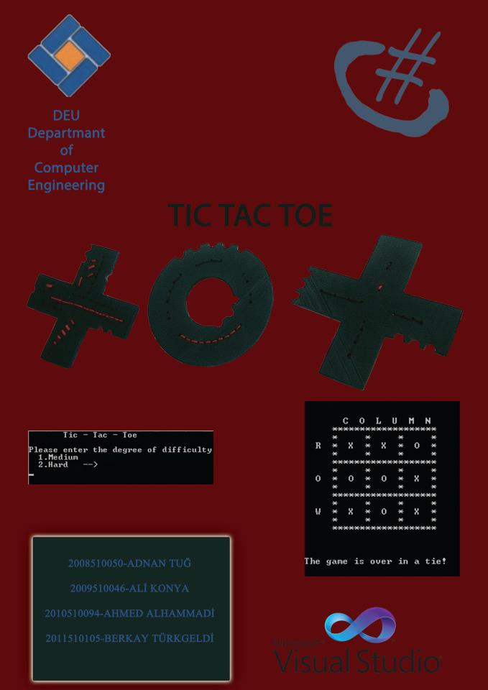

7.2. Code of the Project
Give clear, indented, fully commented code of your project.

